PROJECT REPORT
HireTrack
An Internship Recruitment Tracking System for Early-Stage Startups
___________________________________
Submitted by: Shreya Chopra
Roll No.: 25BBA149
Class: BBA AI & Data Science
Institution: Kristu Jayanti University, Bengaluru
Internship Program: FacePrep Internship Project
Mentor: Ms. Ishika (FacePrep)
Submission Type: Final Project Submission
Academic Year: 2026

1. Abstract
HireTrack is a centralized Internship Recruitment Tracking System designed for early-stage startups that cannot afford enterprise Applicant Tracking Software (ATS). Built entirely on Excel with a companion HTML/CSS/JavaScript web layer, HireTrack gives founders and HR teams a single source of truth for candidate data, hiring pipeline stages, interview outcomes, and recruiter performance — at zero additional software cost. The system comprises five interlinked modules (Candidate Database, Pipeline Tracker, Interview Log, Recruiter Metrics, and a live Dashboard) powered by 38 live Excel formulas, alongside a browser-based landing page and live candidate tracker deployable on GitHub Pages. This report documents the problem motivating the project, the design and implementation approach, the tools used, and the outcomes achieved.

2. Introduction & Problem Statement
Recruitment in early-stage startups is typically run through scattered, ad-hoc spreadsheets maintained independently by different recruiters. This creates four recurring problems that HireTrack directly addresses:
- Scattered Data — every recruiter keeps a separate spreadsheet, so no one has the full picture of the hiring pipeline.
- Missed Follow-Ups — candidates wait days without a response and often accept competing offers.
- No Visibility — founders and leadership have no real-time insight into how many candidates are at each pipeline stage.
- Wasted Hours — teams lose 2+ hours a week simply reconciling duplicate candidate records across sheets.
Industry research consistently shows that the vast majority of early-stage Indian startups operate recruitment entirely through unstructured, manual Excel sheets with no defined pipeline — validating the need for a lightweight but structured solution that does not require an expensive ATS subscription.

3. Objectives
- Design a zero-cost, Excel-native ATS that any startup can adopt without new software or training.
- Centralize candidate data, pipeline stage, interview feedback, and recruiter performance in one workbook.
- Provide a live, auto-updating dashboard giving leadership instant visibility into hiring funnel health.
- Extend the system with a lightweight web layer (landing page + live browser tracker) for easy sharing and demonstration.
- Validate the design against real recruitment workflows using realistic sample data.

4. Existing System vs. Proposed System
Aspect | Without HireTrack | With HireTrack
Data structure | Random, uncoordinated Excel files | One centralized candidate pipeline
Follow-ups | Candidates fall through the cracks | Stage tracker flags every gap
Accountability | No recruiter accountability | Per-recruiter KPI metrics
Visibility | Founders have zero visibility | Live dashboard for leadership
Cost | Enterprise ATS costs ₹50,000+/year | HireTrack costs ₹0 — runs on Excel

5. Tools & Technologies Used
Tool / Technology | Purpose
Microsoft Excel / Google Sheets | Core ATS engine — five linked worksheets forming the entire backend, at zero software cost
Excel Formulas (38 live formulas) | VLOOKUP, IFS, COUNTIFS and data validation drive pipeline automation and KPI calculation
Excel Charts | Bar and pie charts power the auto-updating KPI dashboard
HTML, CSS, JavaScript | Landing page and a live, browser-based candidate tracker with add/edit/delete functionality
GitHub & GitHub Pages | Version control and free static hosting for instant public deployment
Google Fonts (Space Grotesk, JetBrains Mono) | Typography system giving the web layer a clean, modern product feel

6. System Design — Core Modules
HireTrack is organized into five interlinked Excel modules, plus a web layer, described below:

6.1 Candidate Database
Stores full candidate profiles — source, skills, CTC expectations, contact details, and resume link — in one central sheet that every other module references.

6.2 Pipeline Tracker (Status Tracker)
Provides a stage-by-stage view of every candidate: Applied → Screened → Interview → Offer → Joined, using visual checkmarks so gaps are immediately visible.

6.3 Interview Log
Logs interview date, mode, interviewer, feedback ratings, and outcome (Cleared / On Hold / Not Cleared) with color-coded status for quick scanning.

6.4 Recruiter Metrics
Tracks per-recruiter KPIs — calls made, offers extended, rejection rate, and average days-to-hire — to build recruiter accountability.

6.5 Live Dashboard
Aggregates data from all modules into auto-updating summary cards (Joined, Rejected, Conversion %) and charts (e.g. Applications by Source), giving leadership an at-a-glance view of funnel health.

6.6 Website + Web App
A landing page communicates the product's value proposition, backed by a live, browser-based candidate tracker for demonstration and quick data entry outside Excel.

7. Implementation Process
- Research & Planning — studied recruitment gaps across early-stage startups and scoped the five core modules and data model.
- Excel ATS Development — built the Candidate Database, Pipeline Tracker, Interview Log, and Recruiter Metrics sheets, wiring up 38 live formulas.
- Dashboard & Web App — designed the auto-updating KPI dashboard in Excel and coded a companion browser-based live tracker in HTML/CSS/JavaScript.
- Testing & Deployment — validated the workbook with 20 sample candidate records, resolved all formula errors, and deployed the website to GitHub Pages.
The entire system — from problem research to a working, presentable product — was designed and built solo over a three-week period.

8. Screenshots
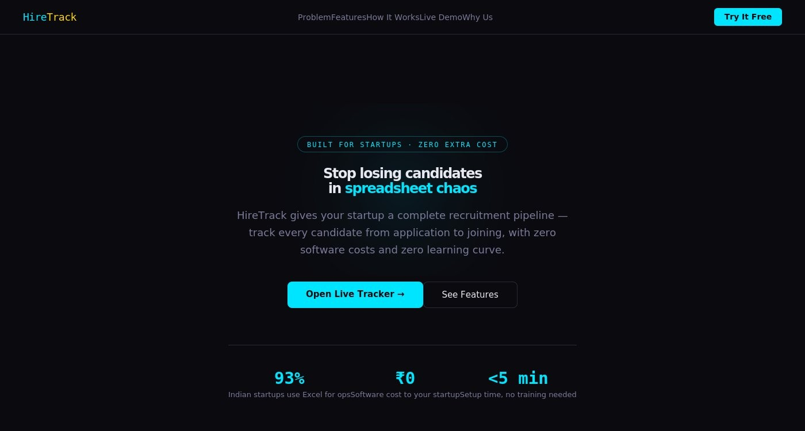
Figure 1: HireTrack landing page hero section
Figure 2: Live browser-based candidate tracker
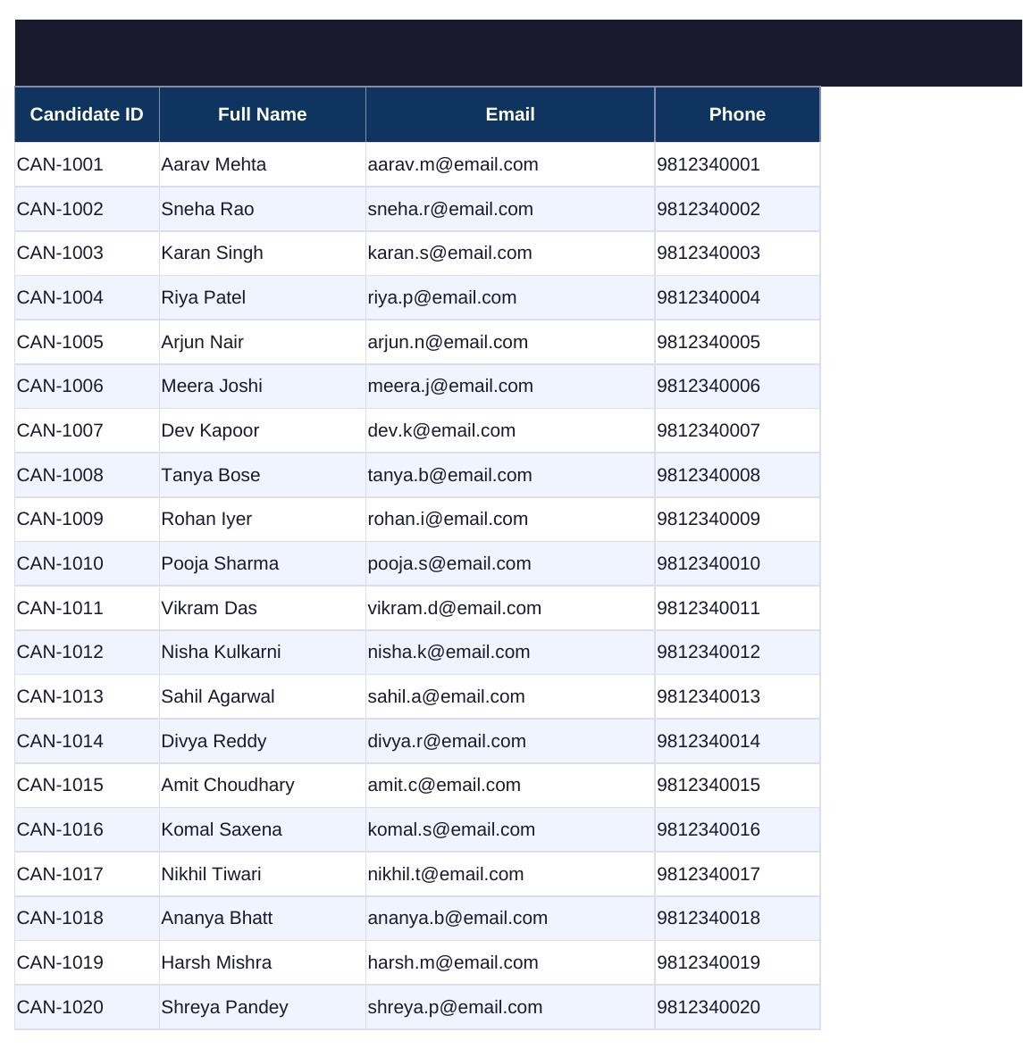
Figure 3: Candidate Database sheet
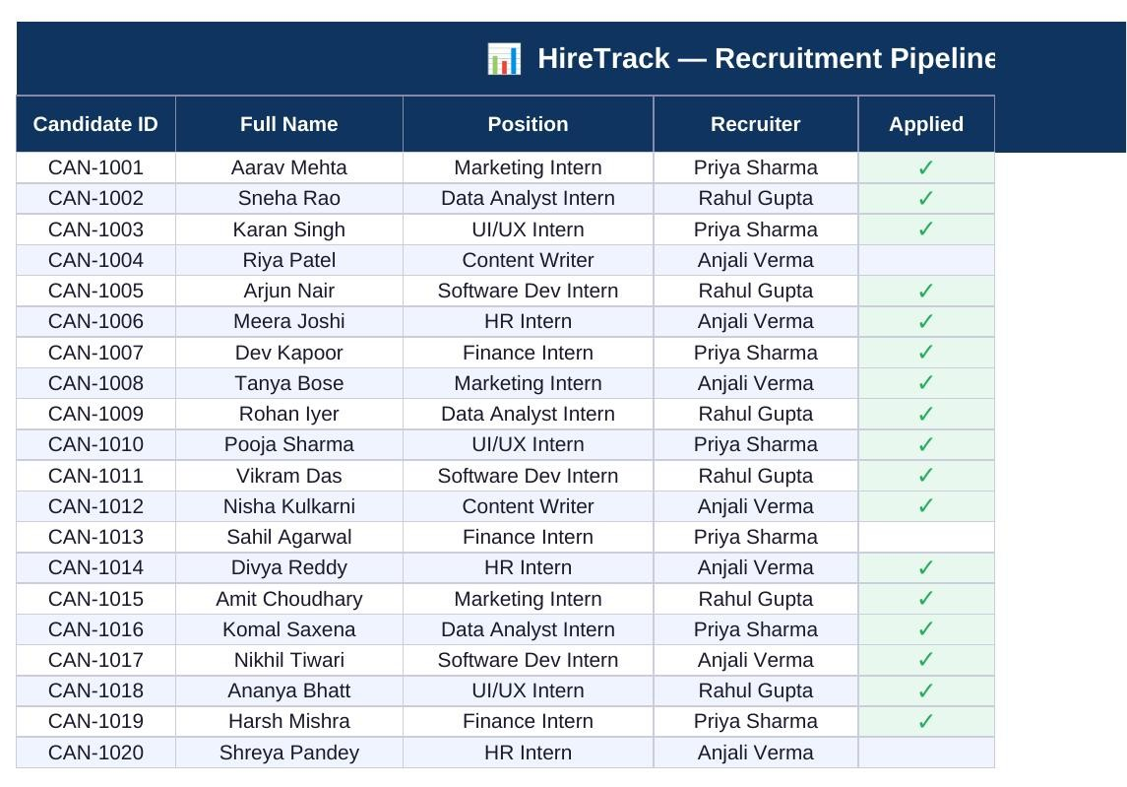
Figure 4: Pipeline / Status Tracker sheet
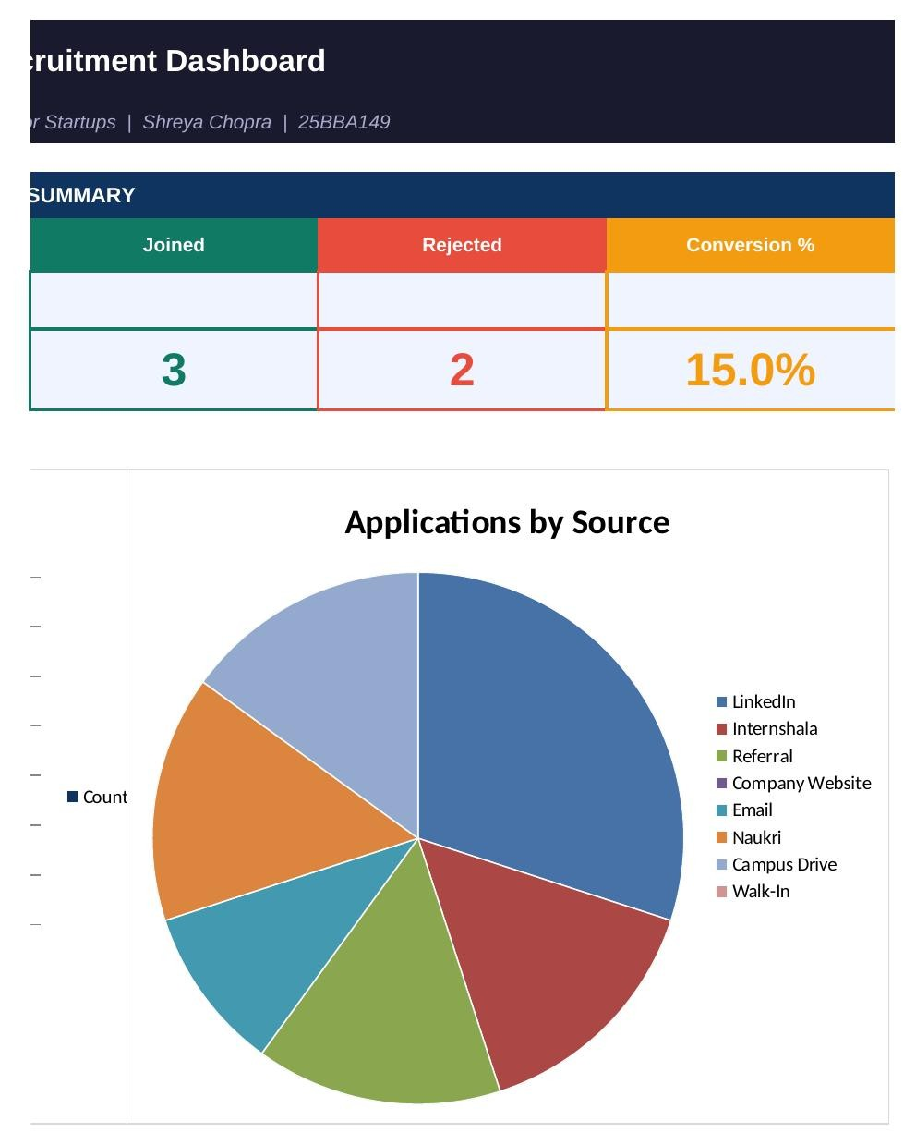
Figure 5: Live Dashboard with KPI summary and charts

9. Testing & Validation
- Populated the workbook with 20 realistic sample candidate records spanning multiple sources, positions, and recruiters.
- Verified all 38 Excel formulas returned correct values with zero formula errors (#REF!, #DIV/0!, #VALUE!, #N/A).
- Manually tested the live browser tracker's add, edit, delete, and search functionality across sample entries.
- Cross-checked dashboard totals (Joined, Rejected, Conversion %) against the underlying Pipeline Tracker and Interview Log data.

10. Results & Impact
HireTrack demonstrates that a fully functional, structured recruitment tracking system can be built without any paid software, using tools startups already have access to. The finished system includes 5 linked modules, 38 error-free live formulas, a working live dashboard, and a deployable web app — collectively replacing the scattered-spreadsheet approach that an estimated 93% of early-stage Indian startups currently rely on. For a startup, adopting HireTrack in place of a ₹50,000+/year enterprise ATS represents a meaningful cost saving with no loss of pipeline visibility or recruiter accountability.

11. Conclusion & Future Scope
HireTrack successfully addresses the core recruitment-tracking pain points faced by early-stage startups — scattered data, missed follow-ups, lack of visibility, and wasted reconciliation time — through a zero-cost, Excel-native ATS backed by a lightweight web layer. Future iterations could extend the system with automated email/WhatsApp follow-up reminders, integration with job-board APIs (LinkedIn, Naukri, Internshala) for automatic candidate import, and a lightweight backend (e.g. Google Sheets API) to let the live web tracker read and write directly to the Excel/Sheets backend in real time.

References
1. Internal research and competitive analysis conducted as part of the HireTrack project scoping phase, 2026.
2. Project repository: https://shreya05-org.github.io/hiretrack/

